<http://127.0.0.1:5500/index.html>

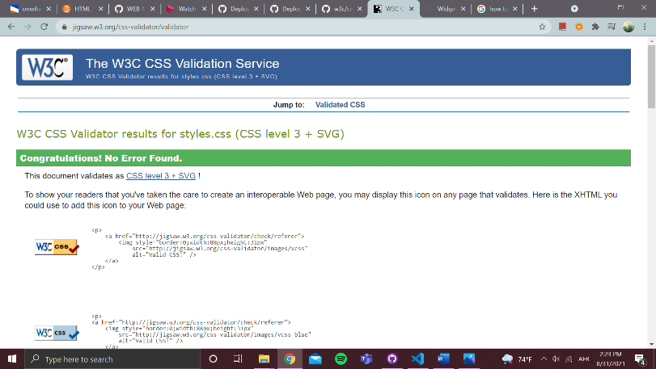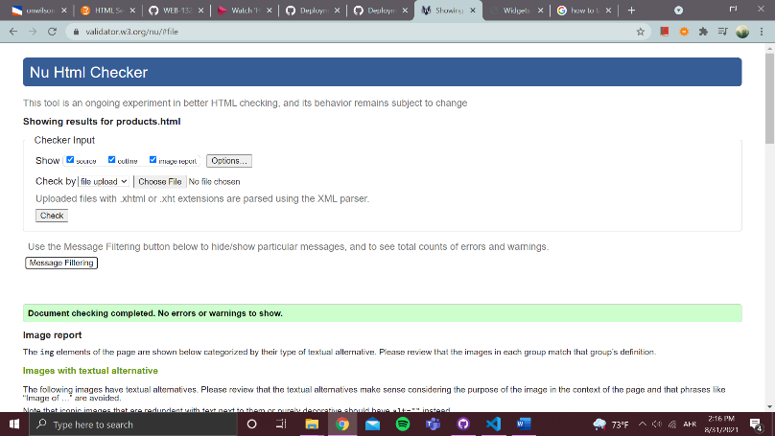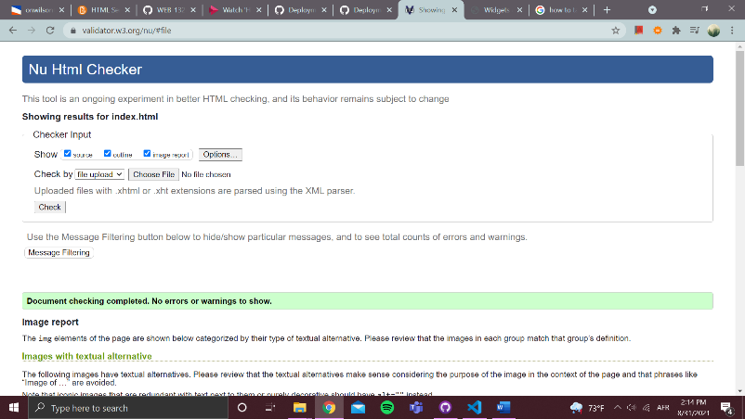HTML Validation

CSS Validation